COGNITIVE WALKTHROUGH



Prof. - Samit Bhattacharya

Saurabh 150101061

Satya 150101060

Abhishek 150101002

Abstract

We evaluated the Tutor app with cognitive walkthrough. We went through several tasks and found that there were some problems that a new user might face. Many problems have to do with lack of feedback and information. At several points a first-time user might feel that they don’t know what available options are there. We have included screenshots and slides for better understanding of this document.

Methodology

The evaluation consisted of the Cognitive Walkthrough process in whihc a group of evaluators reviewed the interface of a website with a given breif description of the target user and were directed to take certain action sequences that would eventually lead to a desired task to complete.

The group consisted of several members with previous knowledge of what a cognitive walkthrough process is, and the group leader. The group leader facilitated the review process with two different types of documents: a document that defined the inputs of the evaluation and a documnet that detailed 4 questions as mentioned in the lecture by Samit Bhattacharya Sir.

Refernce: <http://nptel.ac.in/courses/106103115/21>

During the evaluation, evaluators first followed the sequences given consecutively without interruption and then anwering the 4 questions. Upon completion, the group leader analyze the results and eventually categorized each sequnce as a “Success” or “Needs Improvement”. The inputs are presented further in detail in next pages.

Users

User 1: 18 year old college student. Prior experience with similar apps, and technologically sound.

User 2:20 years old, college student. No prior experience with Virtual classroom learning apps, and a faint assumption on how the app might work.

User 3: 20 years old, college student. Limited prior experience with apps, and somewhat idea of what the app might be.

Task

* Learning the processes of RAM
* Posting a new question on Discussion Forum

QUESTIONS ASKED IN THE WALKTHROUGH NOTES

Will the user try to acheive the right effect?

Will the user notice if the correct action is available?

Will the user associate the correct action with the effect trying to acheived?

If the correct action is performed will the user see that progress is being made towards solution of the task?

1. Introduction

This document gathers the key findings regarding Tutor app project that the team evaluated. By conducting a cognitive walkthrough evaluations and analysis, this report details our findings and recommendations to enhance usability of the Tutor app, particularly “My courses” and “Discussion Forum”

These recommendations are given below in this doc.

Several tasks were identified and walked through. This list might be helpful in identifying what kind of tasks a new user is likely to walk through.

Walkthroughs that we had time to do are summarized and explained in this document. We have attempted to explain our findings in clear words and only short summary of each task’s walkthrough is given.

2. Learning the processes of RAM

This is an important feature in this app. This is one of the main features that this app is built for, if our app is designed in such a way that usablility of this feature is hard, the probability of users coninuing to use this app is small.

* **Task description:** Reading the contens and learing about “RAM”
* **Right execution:**  Search for the desired course, Click on the course “RAM” and then access the course materials for this chapter.
* **Possible problems:** The user might not know from where to access the list of all courses, and may not clearly understand in detail how RAM works.

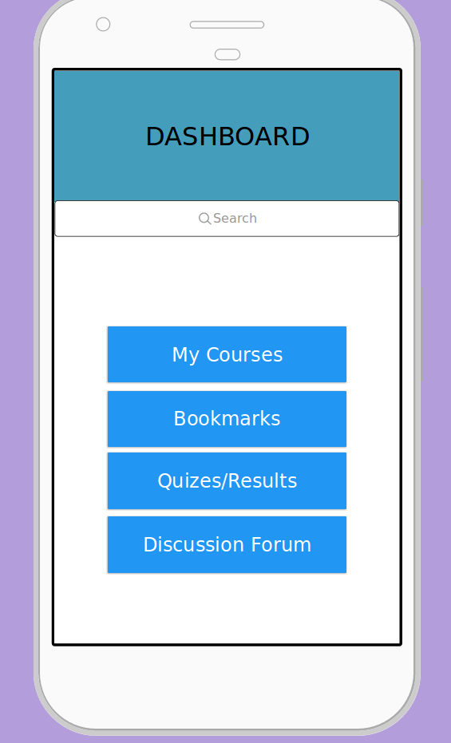

**Screen 1:** First screen after Login. Click on “My courses”

**Screen 2:** List of all courses the user has enrolled in. Select chapter “RAM”

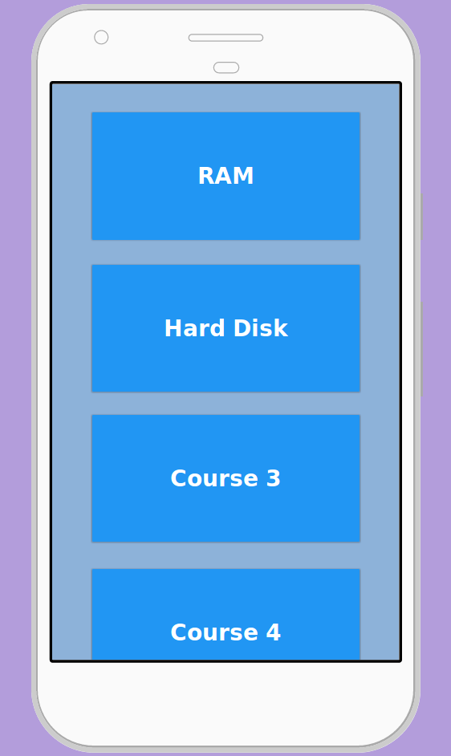

**Screen 3:** Contents of the selected course.

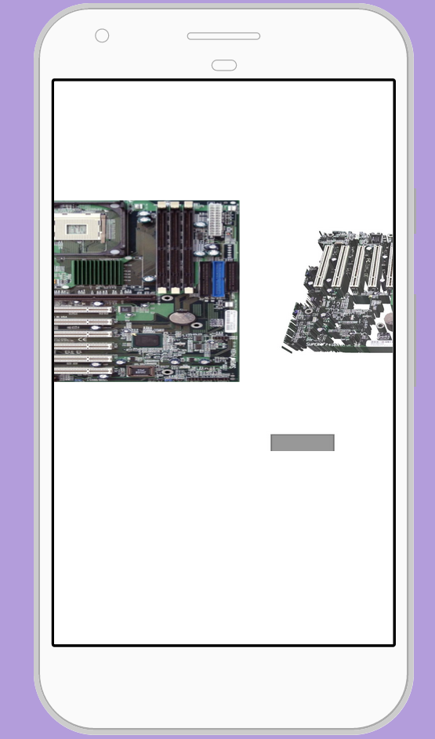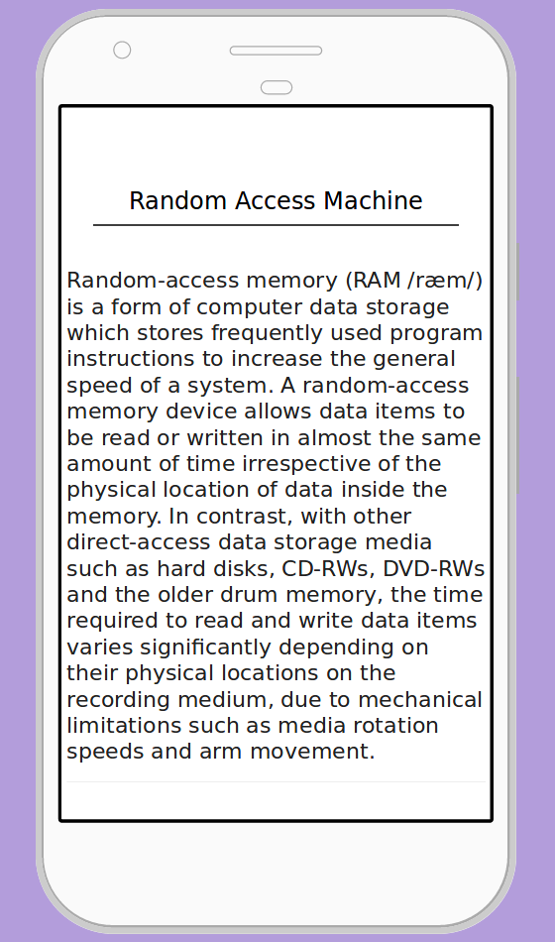

**Sequence of steps by User 1 :**

* Logged in
* Click on “ My courses”
* Clicks and selects the chapter “RAM”
* Reads the first page and then scrolls down to the second screen.
* Views the detailed diagram and 3-D models on RAM.

**Sequence of steps by User 2:**

* Logged in
* Clicks on “My courses”
* Unable to find “RAM” in the list of courses.

**Sequnce of steps by User 3:**

* Logged in
* Clicks on “My courses”
* Reads the first page and then scrolls down to the second screen.
* Is unable to view all the models as they require Horizontal Scrolling.

ACTION 1// ACTION 2

|  |  |  |  |  |
| --- | --- | --- | --- | --- |
|  | Will the user try to acheive the right effect? | Will the user notice if the correct action is available? | Will the user associate the correct action with the effect trying to acheived? | If the correct action is performed will the user see that progress is being made towards solution of the task? |
| User 1 | YES//YES | YES//YES | YES//YES | YES//YES |
| User 2 | YES//NO | YES//NO | YES//-- | YES//NO |
| User 3 | YES//PARTLY | YES//YES | YES//NO | YES//YES |

ACTION 1 = Open “My courses”

ACTION 2= Open and read contents of “RAM”

**Recommendations & Conclusions**

Overall the app was pretty easy to use for experienced users as inferred from the above table,and the experminet, almost all users were sure that they can acheive the right effect. There should be a search box in “My courses” menu to reach the desired course faster if there is a large number of enrolled courses. There should also be a horizontal scroller added beneath the 3-D models of the given topic, for better visibility and navigation.

3. Asking the number of pins in 8085 in Discussion Forum

This feature might be the most used one in the app, since a user needs to constantly ask queries and clear doubts. This feature needs to be quite easy to use, or it will create quite a hassle for the user.

* **Task description:** Asking about the total number of pins in 8085 Architecture.
* **Right execution:** Click on “Discussion Forums” , Click on “Post a new question” and write the new question and post it.
* **Possible problems:** Adding a new question might be difficult for not so seasoned users.

**Screen 1:** This is the first screen after logging in. Click on “Discussion Forum”

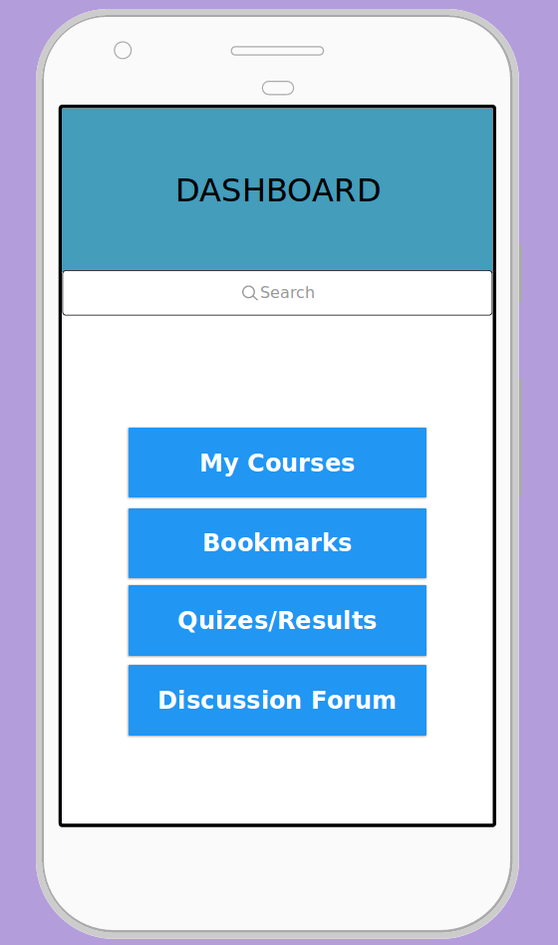

**Screen 2:** Click on “Post a new question”, if the question has not already been asked.

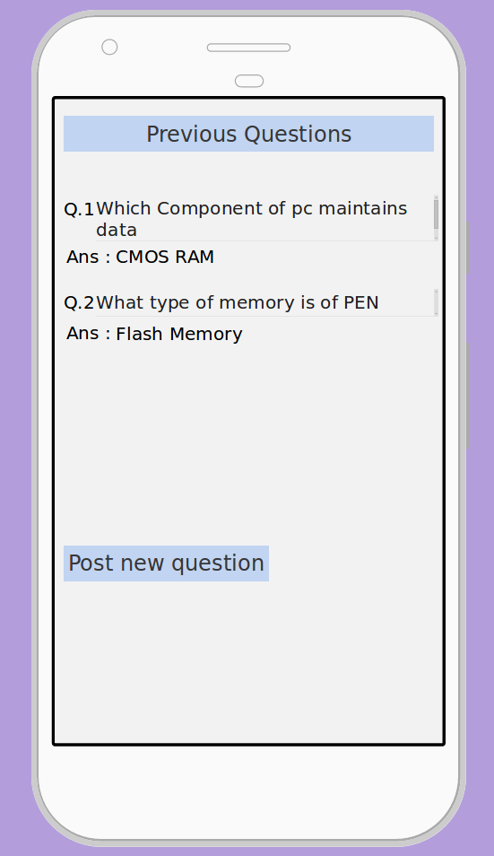

**Screen 3:** Write the new question and post it.

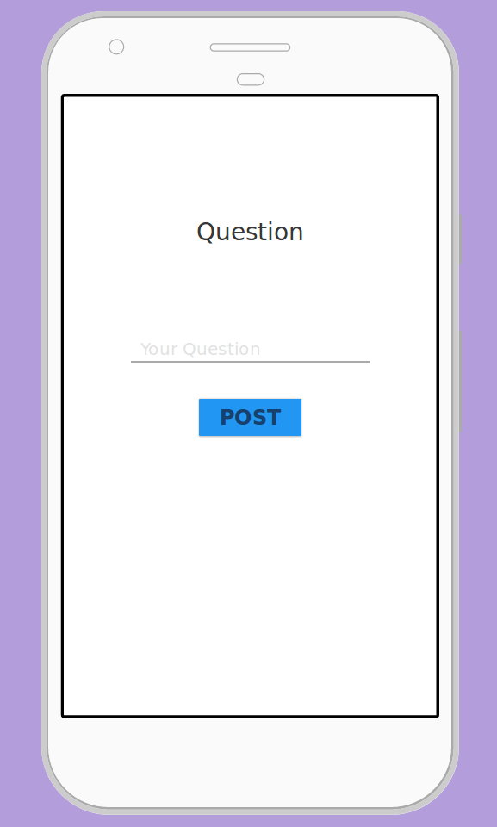

**Sequence of steps by User 1:**

* Logged in
* Clicks on “Discussion Forum”
* Faces some difficulty in finding the “Post a question” button
* Finds the button and clicks on it
* Writes the new question and Clicks on “Post”
* Updates the Forum to view the question

**Sequence of steps by User 2:**

* Logged in
* Clicks on “Discussion Forum”
* Finds the “Post a question” button and click on it
* Writes the question using some mathematical symbols and is unable to post them as they can’t be parsed by the app.

**Sequence of steps by User 3:**

* Logged in
* Clicks on “Discussion Forum”
* Has some difficulty in finding the “Post a question” button
* Finds the button and clicks on it.
* Writes the question and Clicks on “Post”
* Views the Forum, doesn’t find the question
* Posts the question again multiple times

ACTION1//ACTION2

|  |  |  |  |  |
| --- | --- | --- | --- | --- |
|  | Will the user try to acheive the right effect? | Will the user notice if the correct action is available? | Will the user associate the correct action with the effect trying to acheived? | If the correct action is performed will the user see that progress is being made towards solution of the task? |
| User 1 | YES//YES | YES//PARTLY | YES//YES | YES//YES |
| User 2 | YES//YES | YES//YES | YES//NO | YES//NO |
| User 3 | YES//YES | YES//PARTLY | YES//NO | YES//NO |

ACTION 1 = Open the Discussion Forum

ACTION 2 = Posting a question asking about number of pins in 8085 Architecture

**Recommendations & Conclusions**

Action 2 is particularly hard to perform, as only 1 user could even assosciate the progress made with correct action sequence, there is also some error in the searching as one user could not complete the action sequence at all even after knowing the right sequence. In my opinion, the app should give a clear notification of confirmation when the user posts a question, and the app should allow multiple Encodings while searching so as to allow vast array of possible searches.